Introduction to Database

Group Name: Up to Data

Project Name: Diagnostic Center Management System

Course Instructor: Kawser Irom Rushee

Section: C

Group Members Details:

|  |  |
| --- | --- |
| ID | Name |
| 20-42054-1 | Papri Saha |
| 20-42037-1 | Marmita Paul |
| 20-42719-1 | Mahdiya Islam Arbina |
| 20-43313-1 | Shuchi Brata Roy |
| 20-42766-1 | MD.Mosaddek Hossain |

**Case Study**

In a diagnostic center management system, a patient is treated by many technician. One technician can treat many patient. Here,a patient is identified by a patient id. Patient name, Patient’s address, Pgender, patient’s phone number , Page are also stored in computer. There may be multiple phone number of a patient. A patient address is composed of street,city and region. Street is composed of street- number and street- name. A technician is also identified by technician's room no. The computer also stores technician name, technician’s address, Tgender, technician’s phone- number, Tage and qualification. There may be multiple qualification and phone number of a technician. While technician treat patients, the Ptest report and testing date is given to patient. A patient may also pay many investigation fee. A investigation fee may be payed by exactly one patient. Test report fee and instrument fee can be generalized as investigation fee. A patient goes to specific diagnosis room for at least one investigation. One investigation is performed into the specific diagnosis room for at most one patient. Specific Diagnosis room is identified by room name. At the time of going to specific diagnosis room, patient check room number. Investigation can be specialized into routine investigation and specific investigation. Investigation is required for proper treatment. The existence of proper treatment is totally dependent on investigation. Here, proper treatment is identified by a treatment room no. Hospital’s Treatment room name is also stored in diagnosis room’s computer. Now draw an ER diagram according to the mentioned scenario.

**ER Diagram**

**Screenshot Jpg Format:**

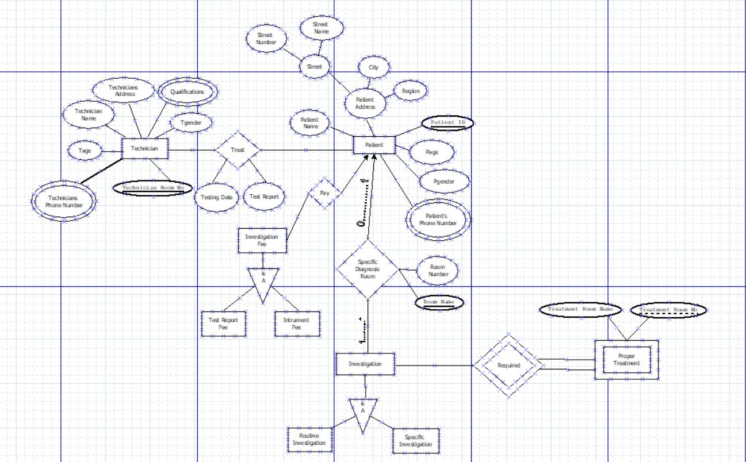

**Screenshot From Dia Software :**

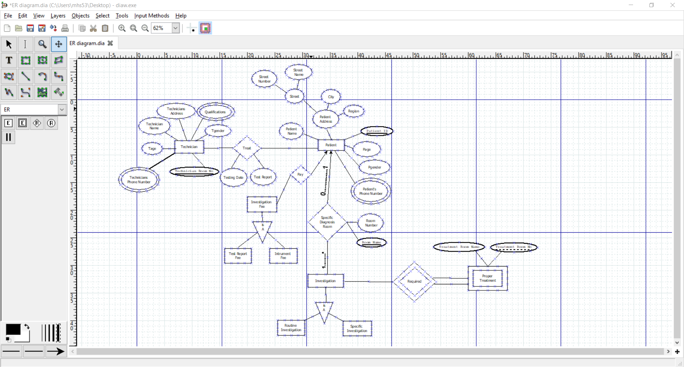

**Normalization**

**Treat:**

**UNF:1st:** technician name, technician address, qualification, Tgender, technician’s phone number,Tage, technician’s room no, patient name, street- number, street- name, city, region, Page, Pgender, patient’s phone number, patient id, Ptesting date, test report

**1NF:1st:.** technician’s room no, technician’s phone number, qualification , patient id, patient’s phone number , technician name, technician address, Tgender, Tage, patient name, street- number, street- name, city, region, Page, Pgender, Ptesting date, test report

**2NF:1st:** technician’s room no, technician’s phone number, qualification , technician name, Tgender, Tage

**2nd:** technician’s room no, technician’s phone number , technician address

**3rd:** patient id**,**  patient’s phone number , patient name, street- number, street- name, city, region, Page, Pgender

**4th:** patient id, test report, Ptesting date

**3NF: 1st:** technician’s room no, technician’s phone number, qualification , technician name, Tgender, Tage

**2nd:** technician’s room no,technician’s phone number **,** technician address

**3rd:** patient id, patient’s phone number , patient name, city, Page, Pgender

**4th:** City , street- number, street- name, region

**5th:** patient id,test report, Ptesting date

**Pay:**

**UNF: 1st:** patient id, patient’s phone number , patient name, street- number, street- name, city, region, Page, Pgender, test report fee, instrument fee

**1NF:1st:** patient id, patient’s phone number , patient name, street- number, street- name, city, region, Page, Pgender, test report fee, instrument fee

**2NF:1st:** patient id, patient’s phone number , patient name, street- number, street- name, city, region, Page, Pgender, test report fee, instrument fee

**3NF:1st:** patient id, patient’s phone number , patient name, city, Page, Pgender, test report fee

**2nd:** City , street- number, street- name, region

**3rd:** test report fee, instrument fee

**Specific diagnosis room:**

**UNF:1st:** patient id, patient’s phone number , patient name, street- number, street- name, city, region, Page, Pgender, routine investigation, specific investigation, room name, room number

**1NF:1st:** patient id, patient’s phone number , room name, patient name, street- number, street- name, city, region, Page, Pgender, routine investigation, specific investigation, room number

**2NF:1st:** patient id, patient’s phone number , patient name, street- number, street- name, city, region, Page, Pgender

**2nd:** room name, routine investigation, specific investigation, room number

**3NF:1st:** patient id, patient’s phone number , patient name, city, Page, Pgender,

**2nd:** City , street- number, street- name, region

**3rd:** room name, routine investigation, specific investigation, room number

**Required:**

**UNF:1st:** routine investigation, specific investigation, treatment room name, treatment room no

**1NF:1st:** treatment room no**,** routine investigation, specific investigation, treatment room name

**2NF:2nd:**treatment room no**,** routine investigation, specific investigation, treatment room name

**3NF:1st:** treatment room no, treatment room name, routine investigation, specific investigation

**Final Table:**

**1st**: technician’s room no, technician’s phone number, qualification , technician name, Tgender, Tage

**2nd:** technician’s room no, technician’s phone number , technician address

**3rd:** patient id, patient phone number , patient name, city, Page, Pgender

**4th:** City , street- number, street- name, region

**5th:** patient id, test report, Ptesting date

**6th:** patient id, patient’s phone number , patient name, city, Page, Pgender, test report fee

**7th:** test report fee, instrument fee

**8th:** room name, routine investigation, specific investigation, room number

**9th:** treatment room no, treatment room name, routine investigation, specific investigation

**Table Creation**

**1. Technician**

CREATE TABLE Technician_Info1 (

Technician_Room_No number(20),

Technician_Name varchar2(50),

Technician_Phone_No number(14),

Qualification varchar2(40),

Tage number(2),

Tgender varchar2(10),

primary key(Technician_Room_No,Technician_Phone_No,Qualification));

Table Screenshot:

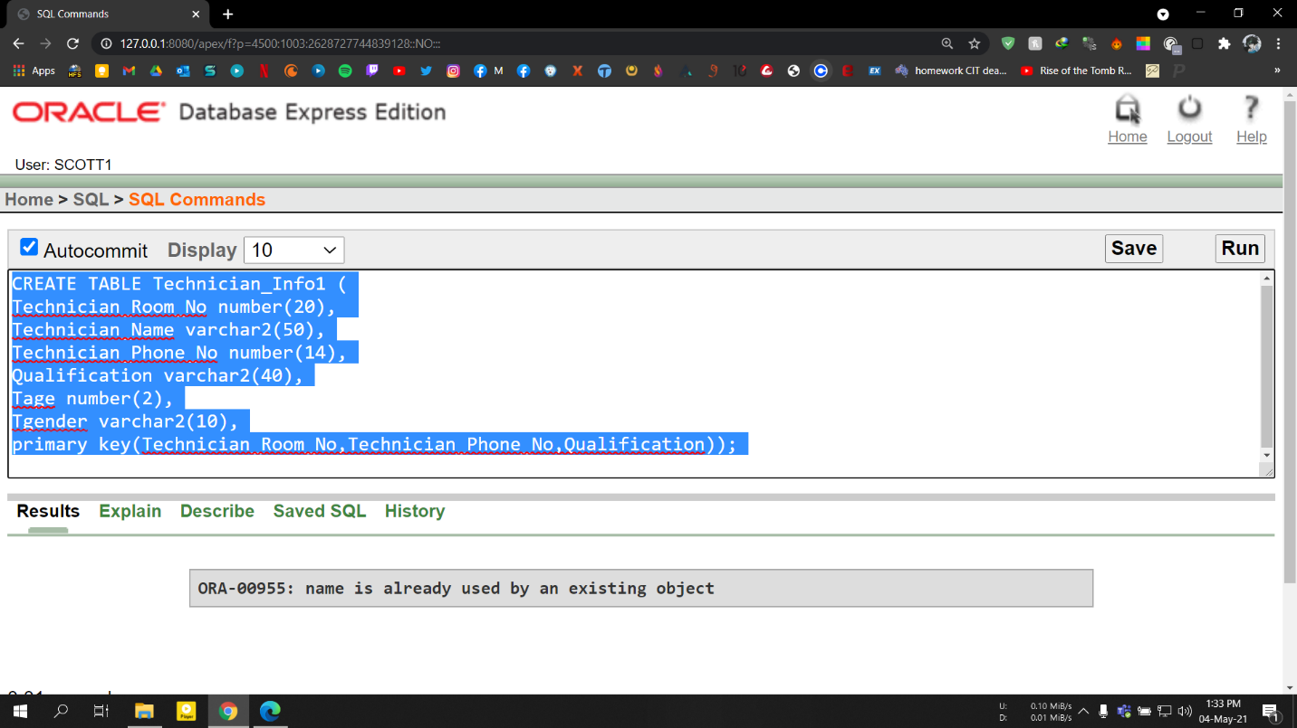

**2.Technician Info**

CREATE TABLE Technician_Info2(

Technician_Room_No number(20),

Technician_Phone_No number(14),

Technician_Address varchar2(10),

primary key(Technician_Room_No,Technician_Phone_No)

);

Table Screenshot:

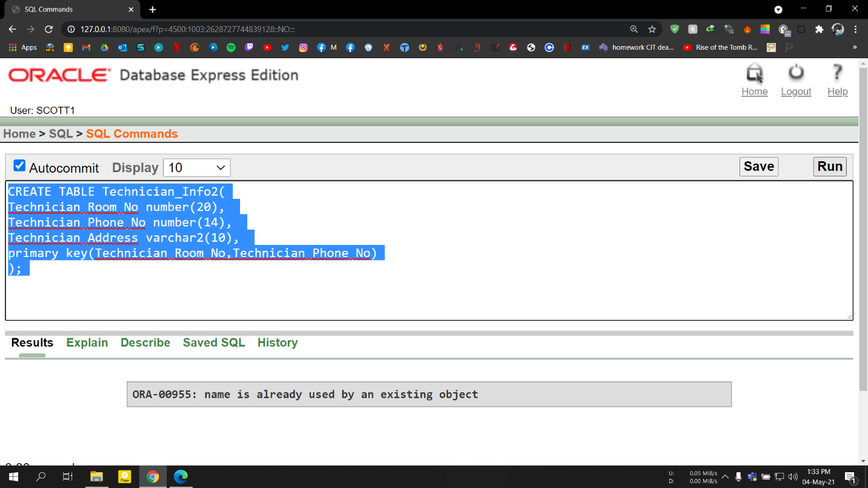

**3.Patient**

CREATE TABLE Patient (

Patient_id number(20),

Patient_Name varchar2(50),

Patient_Phone_No number(14),

City varchar2(40),

Page number(2),

Pgender varchar2(10),

primary key(Patient_id,Patient_Phone_No));

Table Screenshot:

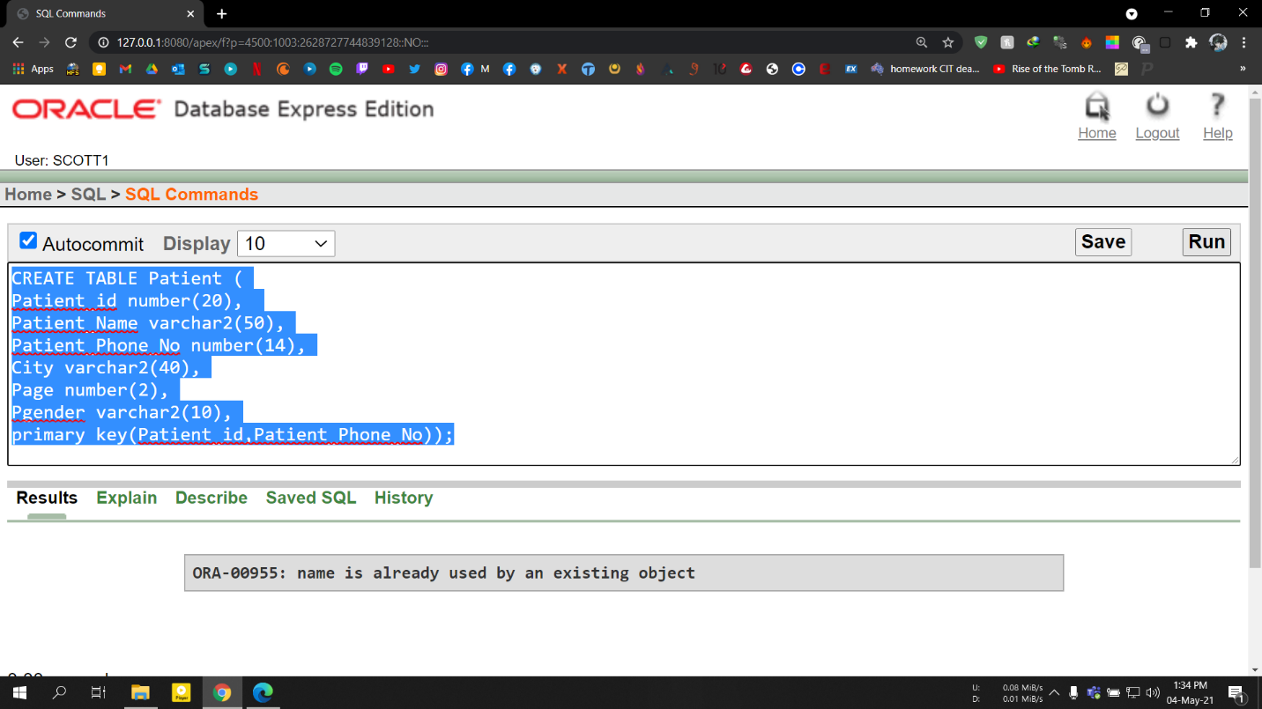

**4. City**

CREATE TABLE City (

City varchar2(50) primary key,

Street_Number number(14),

Street_Name varchar2(40),

Region varchar2(10)

);

Table Screenshot:

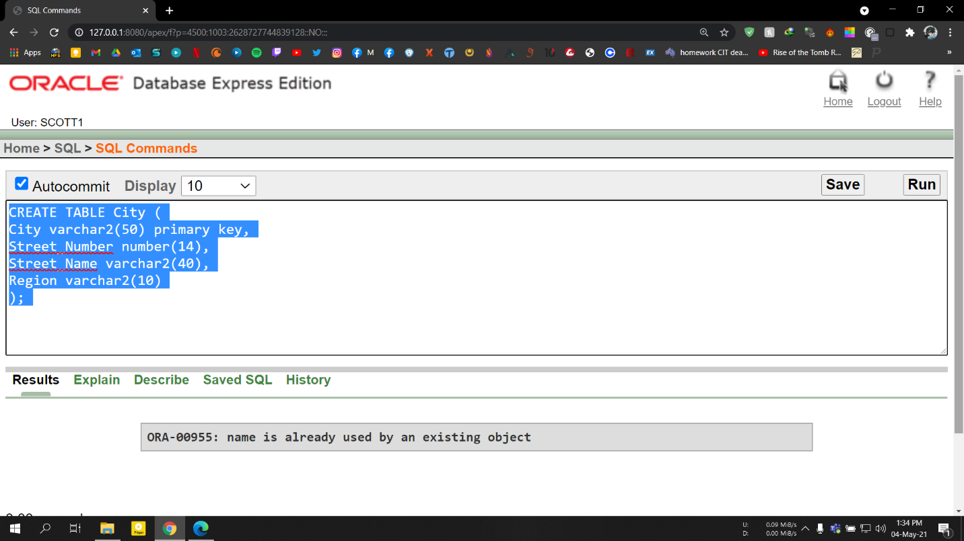

**5.Patient Info1**

CREATE TABLE Patient_Info1(  
Patient_id number(20),  
Test_Report varchar2(100),  
Ptesting_date date not null,  
primary key(Test_Report)

);

Table Screenshot: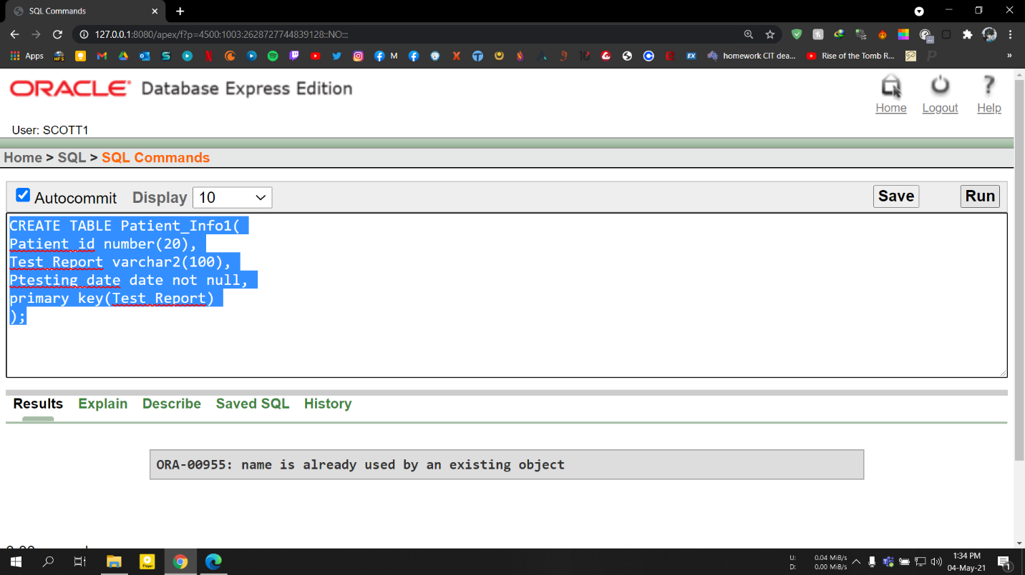

**6.Patient Info2**

CREATE TABLE Patient_Info2(

Patient_id number(20),

Patient_Name varchar2(50),

Patient_Phone_No number(14),

City varchar2(40),

Page number(2),

Pgender varchar2(10),

Test_Report_Fee number(10),

primary key(Patient_id,Patient_Phone_No))

Table Screenshot:

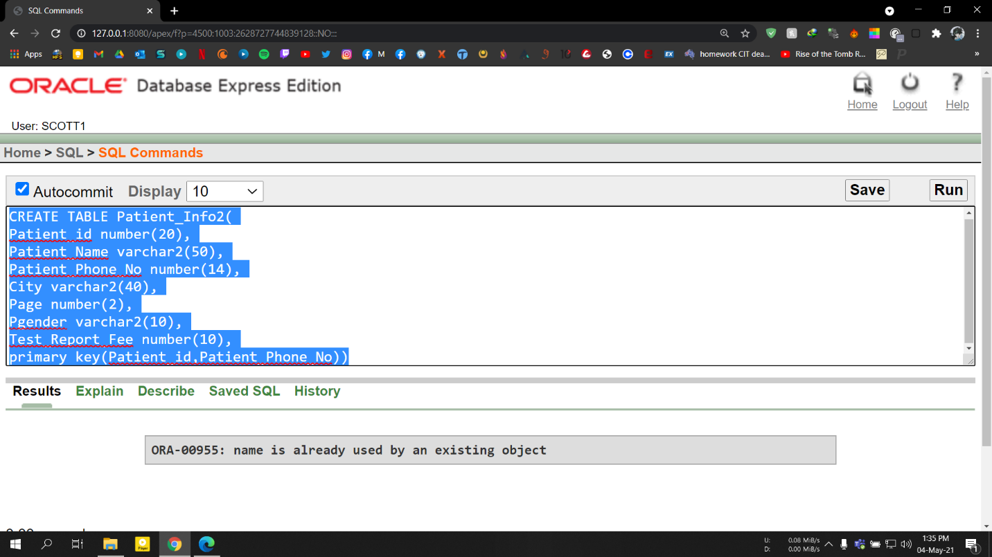

**7.Test Report**

CREATE TABLE Test_Report (

Test_Report_Fee number(10) primary key,

Instrument_Fee number(10)

);

Table Screenshot:

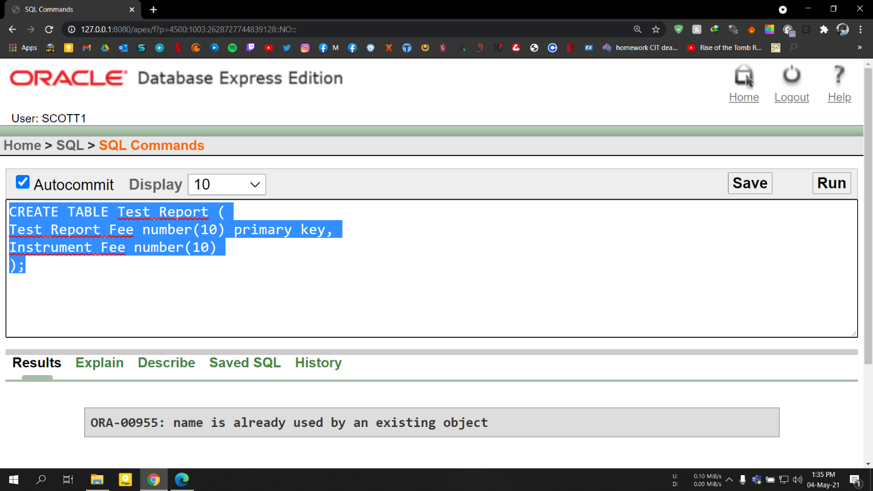

**8. Room Name**

CREATE TABLE Room_Name (

Room_Name varchar2(10) primary key,

Routine_Investigation varchar2(50),

Specific_Investigation varchar2(50),

Room_Number number(10)

);

Table Screenshot:

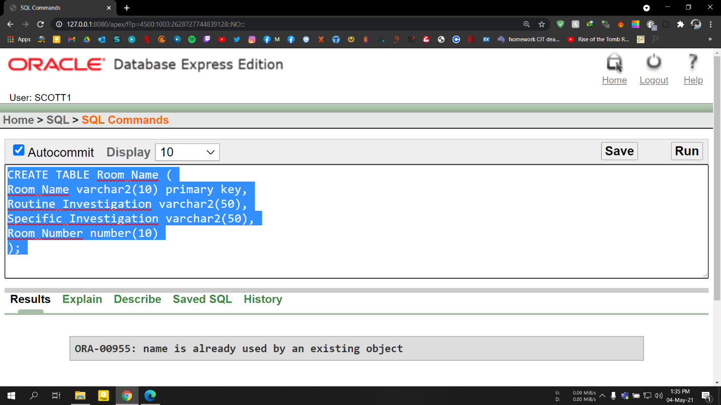

**9. Treatment Room**

CREATE TABLE Treatment_Room (

Treatment_room_no number(10) primary key,

Treatment_room_Name varchar2(20),

Routine_Investigation varchar2(50),

Specific_Investigation varchar2(50)

);

Table Screenshot

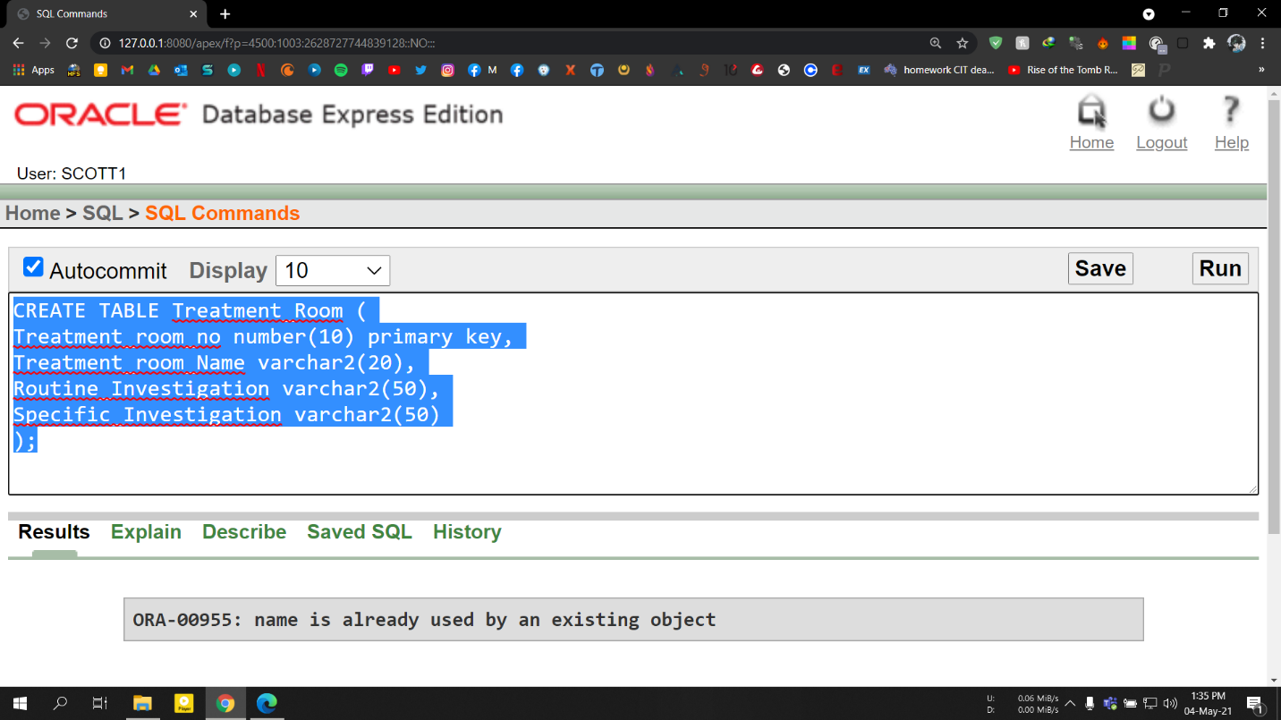

**Data Insertion**

**1. Technician**

INSERT INTO Technician_Info1

VALUES (304,'Mr. koushik',+8801819471121,'B.Sc in medical laboratory technology',28,'Male');

INSERT INTO Technician_Info1

VALUES (103,'Mrs. Asma',+8801745216636,'B.Sc in Dialysis',26,'Female');

INSERT INTO Technician_Info1

VALUES (247,'Mr. Ahmed',+8801929298982,'M.Sc in Medicine',30,'Male');

**Screenshot:**

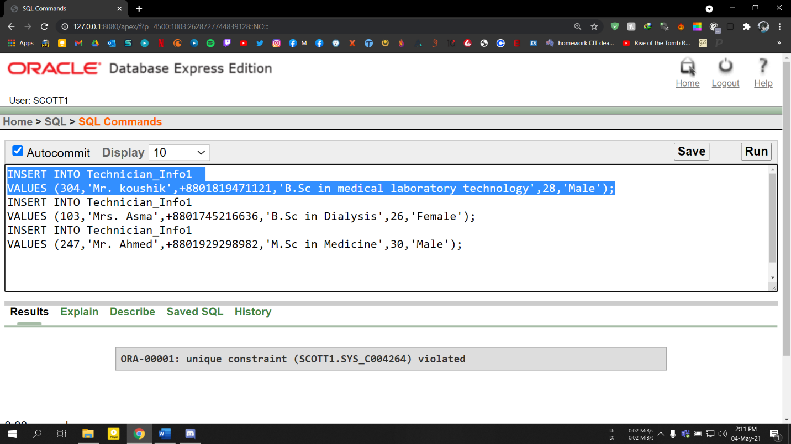

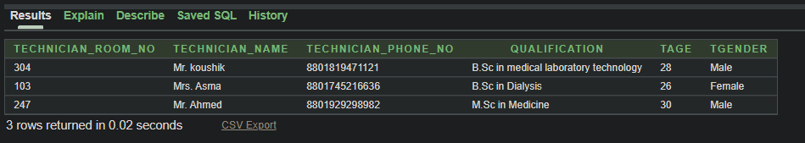

**2.Technician Info**

INSERT INTO Technician_Info2

VALUES (304,+8801819471121,'Comilla');

INSERT INTO Technician_Info2

VALUES (103,+8801745216636,'Basundhara');

INSERT INTO Technician_Info2

VALUES (247,+8801929298982,'Uttara');

**Screenshot:**

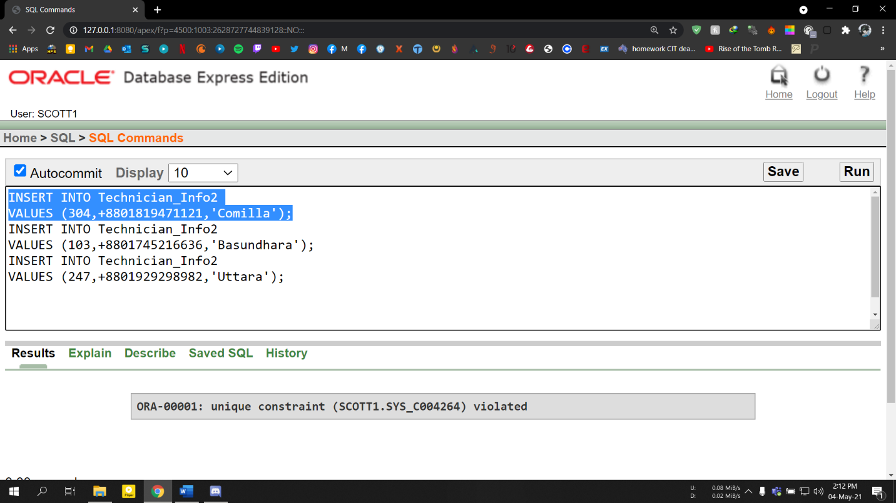

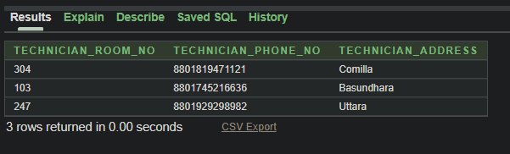

**3.Patient**

INSERT INTO Patient

VALUES (202110,'Soumik Roy',+8801780363359,'Bandar',35,'Male');

INSERT INTO Patient

VALUES (202117,'Mahdiya Arbina',+8801789437321,'Sirajgonj',29,'Female');

INSERT INTO Patient

VALUES (2021320,'Marmita',+8801780564632,'Golachipa',22,'Female');

**Screenshot:**

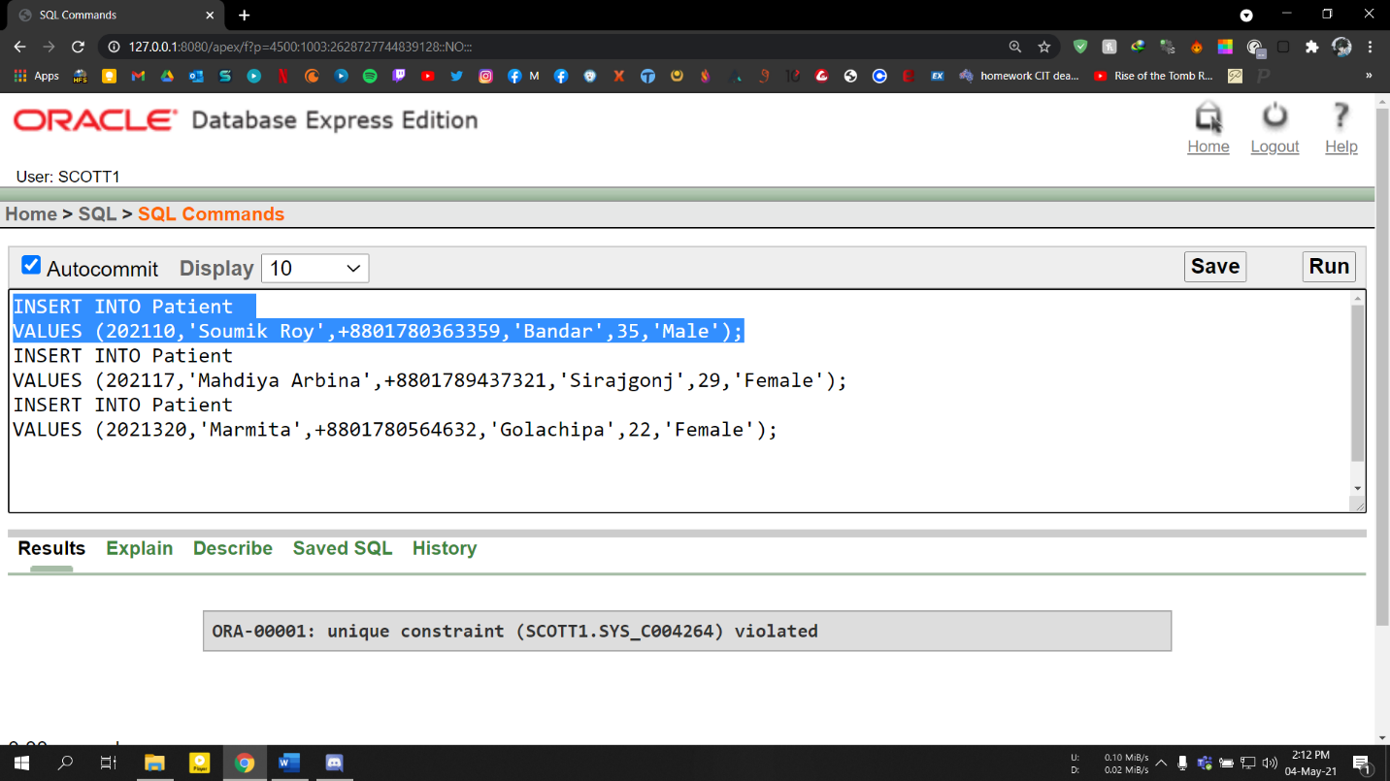

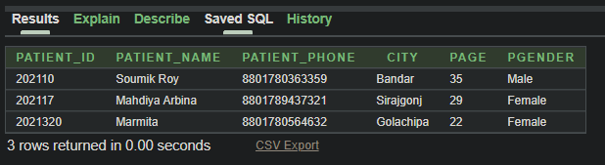

**4. City**

INSERT INTO City

VALUES ('Bandar',175,'College Road','Bangladesh');

INSERT INTO City

VALUES ('Sirajgonj',112,'K.c Dhor road','Bangladesh');

INSERT INTO City

VALUES ('Golachipa',286,'Amlapara','Bangladesh');

**Screenshot:**

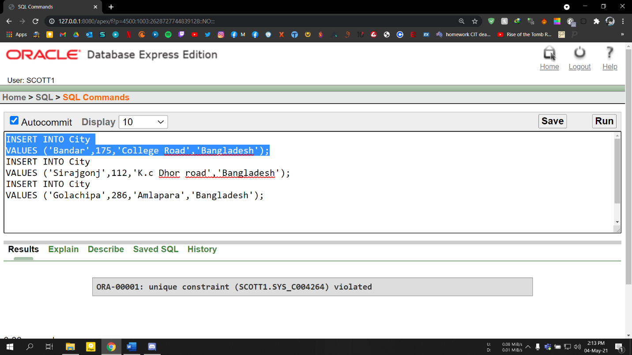

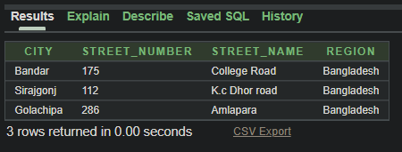

**5.Patient Info1**

INSERT INTO Patient_Info1

VALUES (202110,'Surgical Pathology Report','20-JUN-21');

INSERT INTO Patient_Info1

VALUES (202117,'Psychological Report','03-APRIL-20');

INSERT INTO Patient_Info1

VALUES (2021320,'Heart Dignosis Report','04-DEC-21');

**Screenshot:**

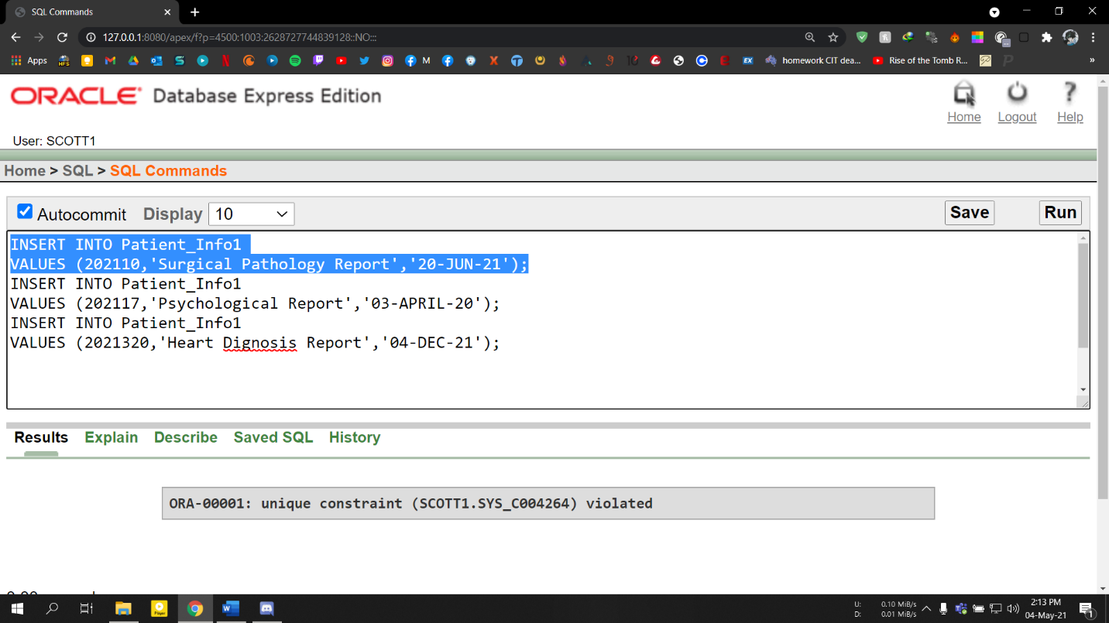

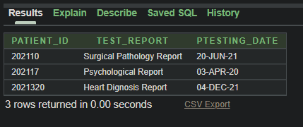

**6.Patient Info2**

INSERT INTO Patient_Info2

VALUES (202110,'Soumik Roy',+8801780363359,'Bandar',35,'Male',950);

INSERT INTO Patient_Info2

VALUES (202117,'Mahdiya Arbina',+8801789437321,'Sirajgonj',29,'Female',1000);

INSERT INTO Patient_Info2

VALUES (2021320,'Marmita',+8801780564632,'Golachipa',22,'Female',880);

**Screenshot:**

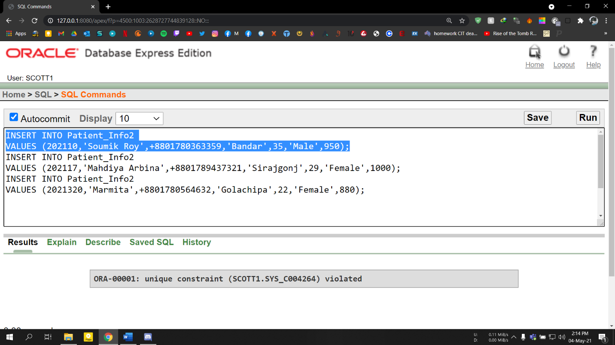

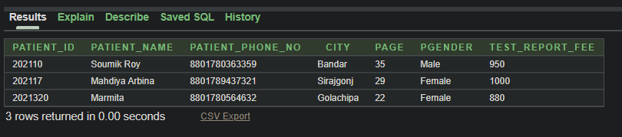

**7.Test Report**

INSERT INTO Test_Report

VALUES (950,1000);

INSERT INTO Test_Report

VALUES (1000,1200);

INSERT INTO Test_Report

VALUES (880,2900);

**Screenshot:**

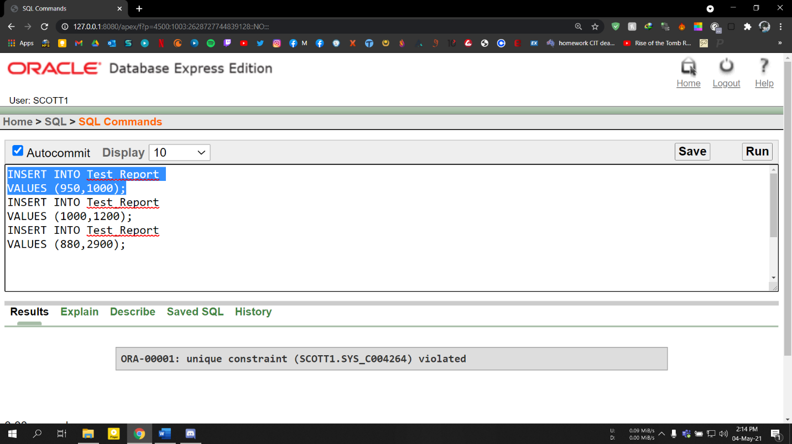

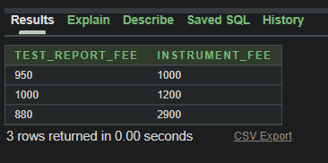

**8. Room Name**

INSERT INTO Room_Name

VALUES ('Medi Lab','Saturday,Tuesday,Thursday','Sunday',101);

INSERT INTO Room_Name

VALUES ('Consultant','Friday,Tuesday,Thursday','Monday',307);

INSERT INTO Room_Name

VALUES ('ECG Lab','Saturday,Wednesday','Friday',10);

**Screenshot:**

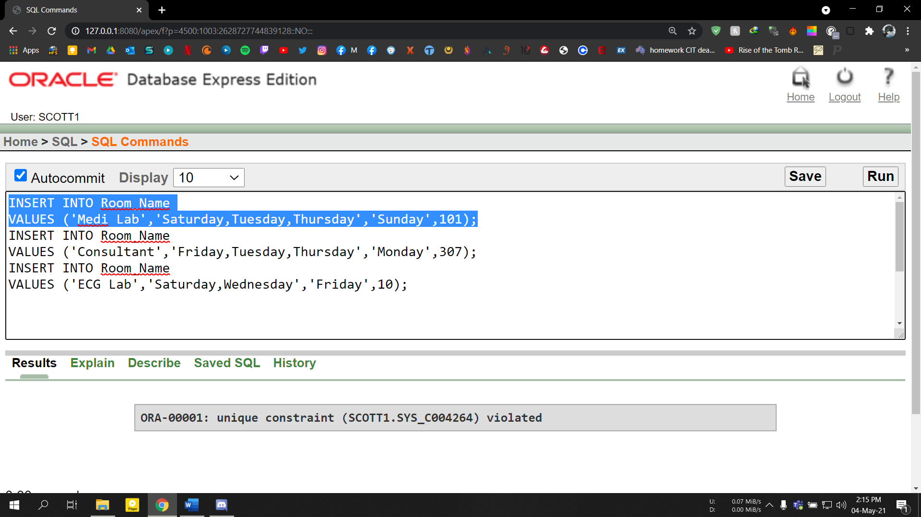

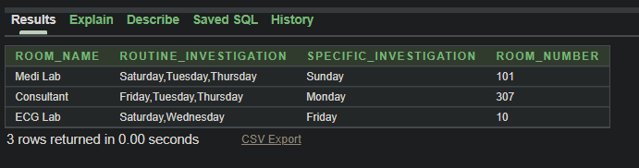

**9. Treatment Room**

INSERT INTO Treatment_Room

VALUES (09,'Surgery Lab','Saturday','Wednesday');

INSERT INTO Treatment_Room

VALUES (101,'Discussion Room','Friday','Monday');

INSERT INTO Treatment_Room

VALUES (309,'Heart Dignosis Lab','Wednesday','Friday');

**Screenshot:**

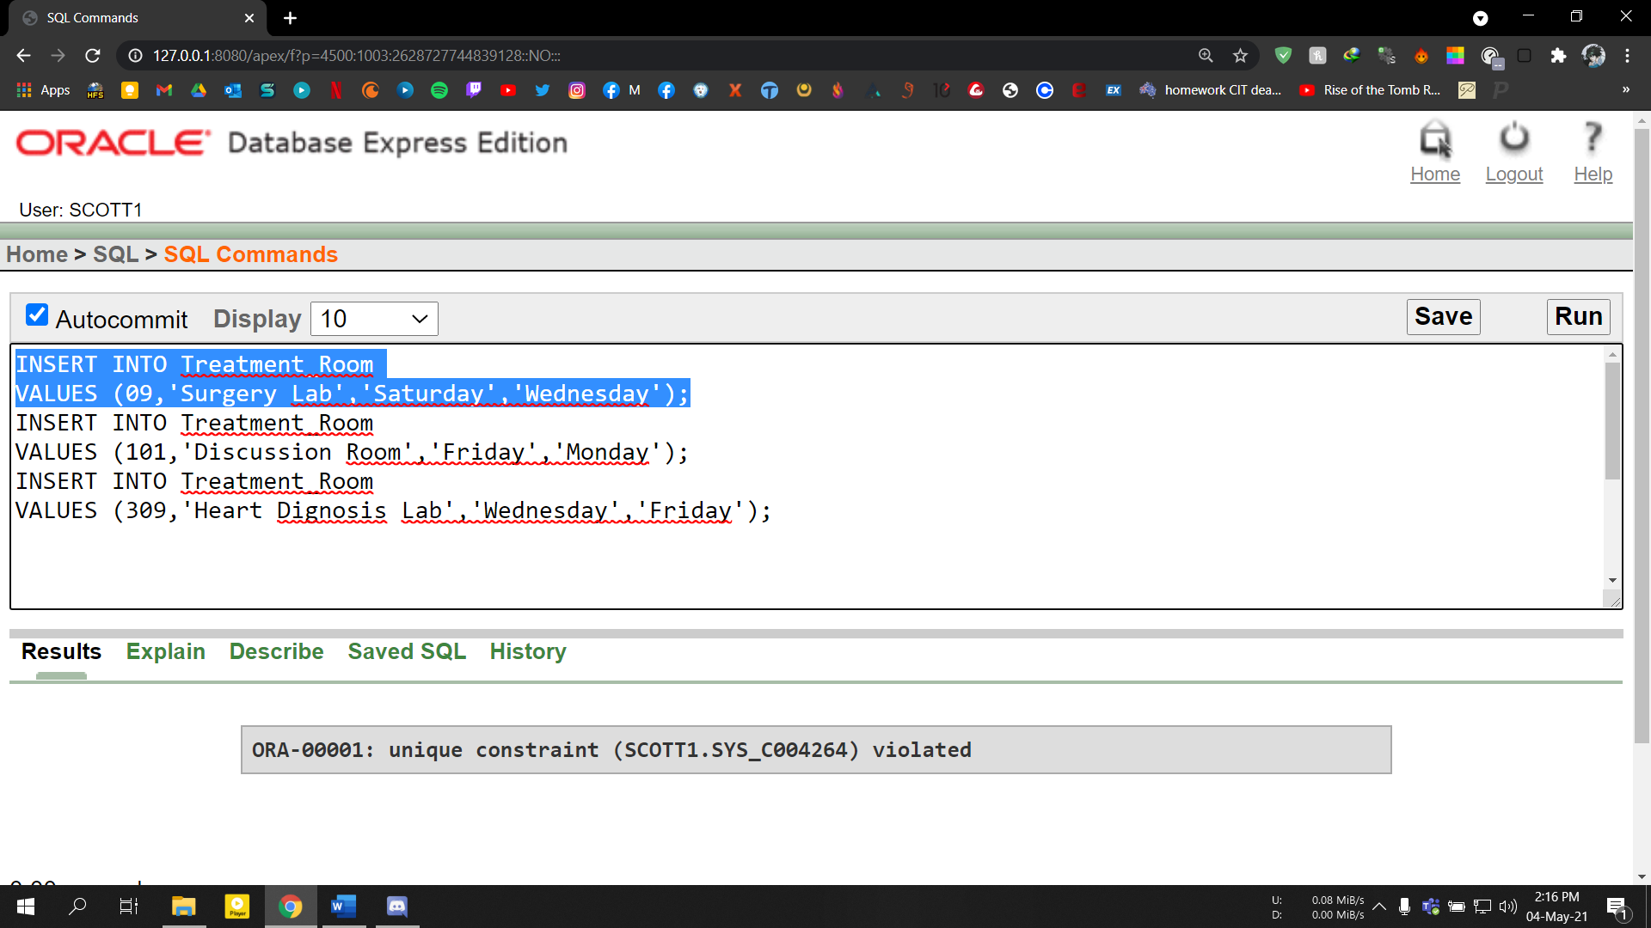

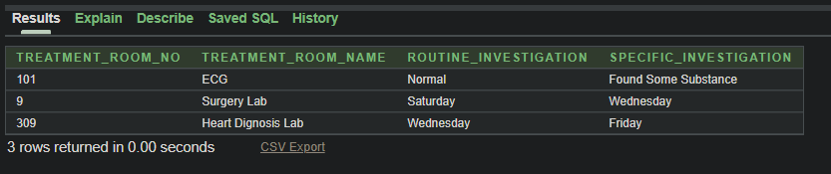

**Joining**

**Equijoin 01:**

select Technician_Info1.Technician_Room_No,Technician_Info1.Technician_Name,Technician_Info2.Technician_Phone_No,Technician_Info2.Technician_Address

from Technician_Info1,Technician_Info2

where Technician_Info1.Technician_Phone_no=Technician_Info2.Technician_Phone_No;

**Screenshot:**

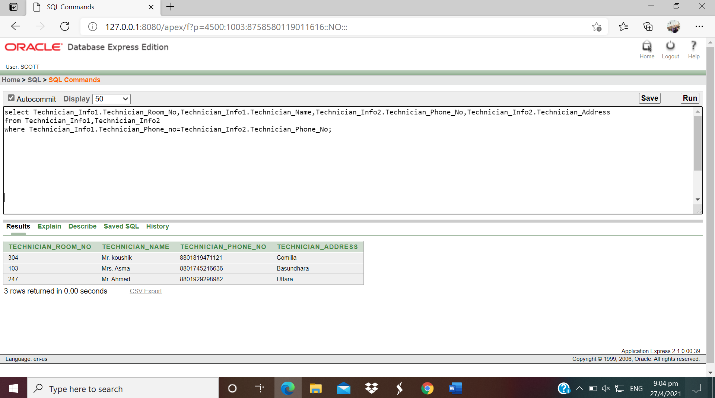

**Equijoin 02:**

select Patient.Patient_Id,Patient.Patient_Name,Patient_Info1.Test_Report,Patient_Info1.Ptesting_Date

from Patient,Patient_Info1

where Patient.Patient_Id=Patient_Info1.Patient_Id;

**Screenshot:**

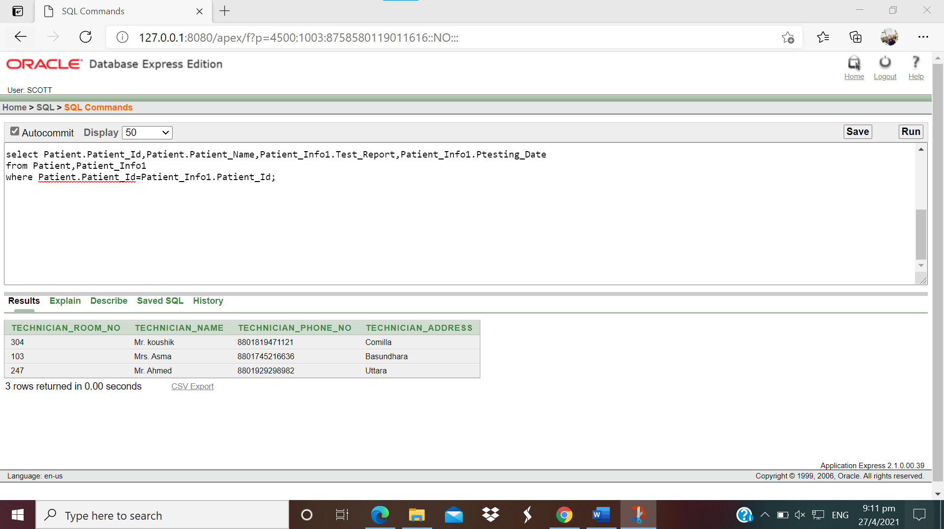

**Outer Join:**

select Technician_Info1.Technician_Room_No,Technician_Info2.Technician_Phone_No

from Technician_Info1

full outer join Technician_Info2 on Technician_Info1.Technician_Phone_No=Technician_Info2.Technician_Phone_No

order by Technician_Info1.Technician_Room_No;

**Screenshot:**

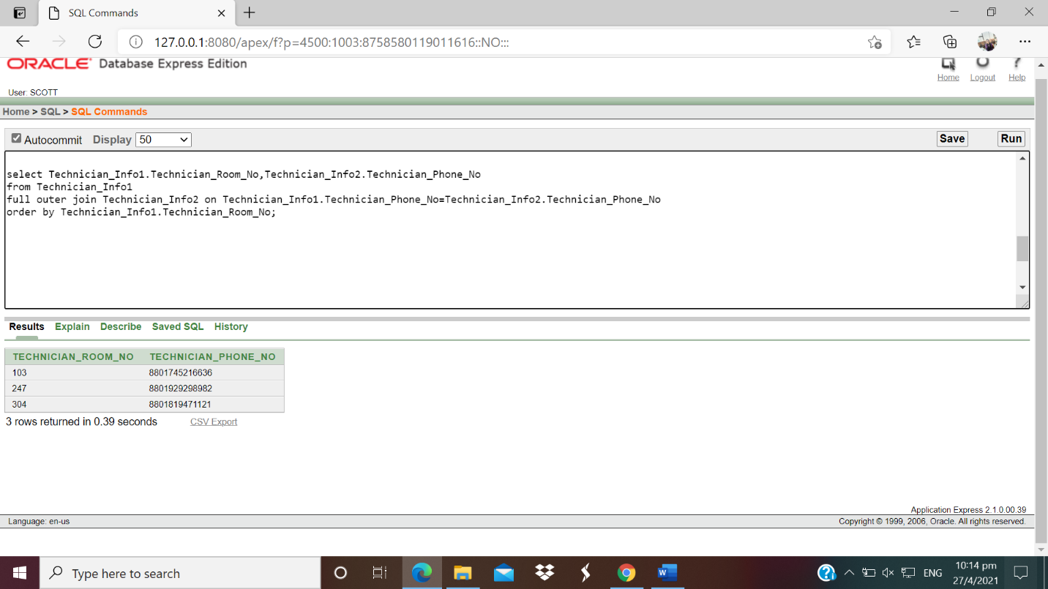

**Self Join:**

select Patient.Patient_Name as Patient_Name1,Patient_Info2.Patient_Name as Patient_Name2,Patient.City

from Patient,Patient_Info2

where Patient.Patient_Id=Patient_Info2.Patient_Id

And Patient.City=Patient_Info2.City

Order by Patient.City;

**Screenshot:**

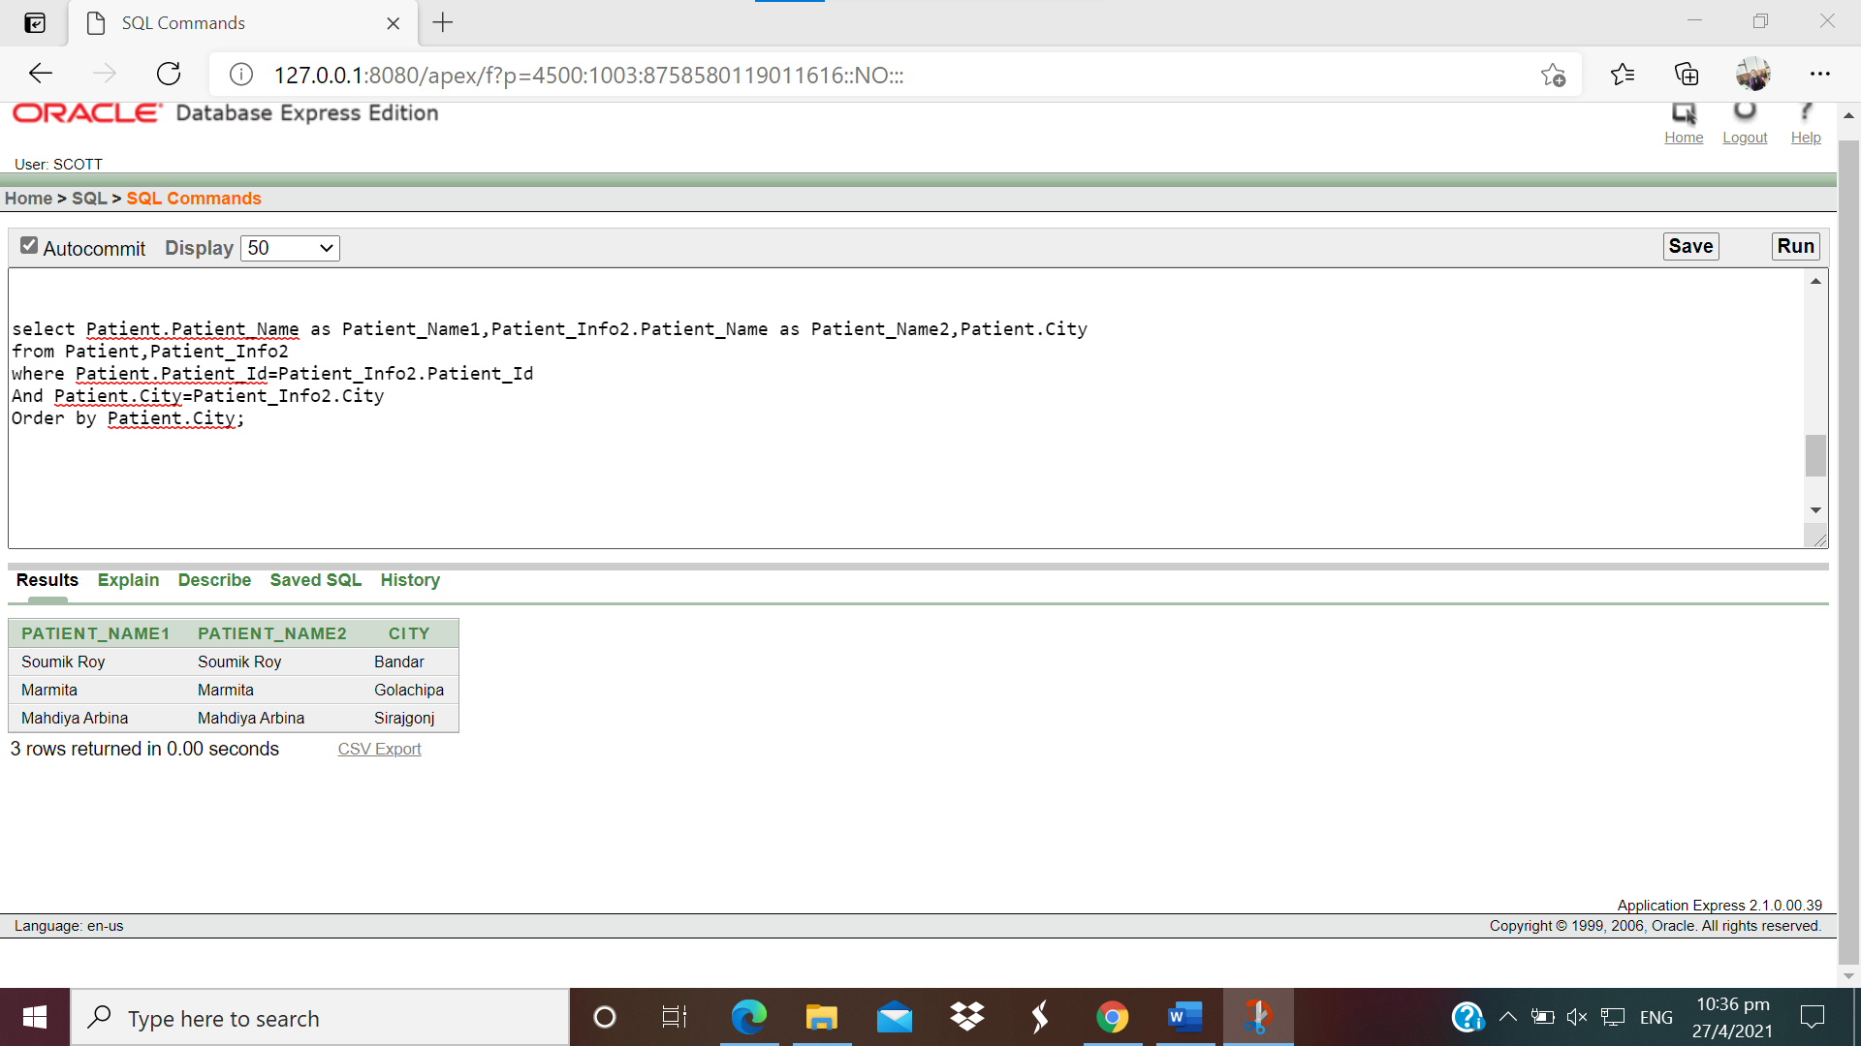

**Subquery**

**1. Find the patientname, city who lives in Bangladesh**

SELECT patient_name, city

FROM patient

WHERE city IN (SELECT city FROM city where region='Bangladesh');

**Screenshot:**

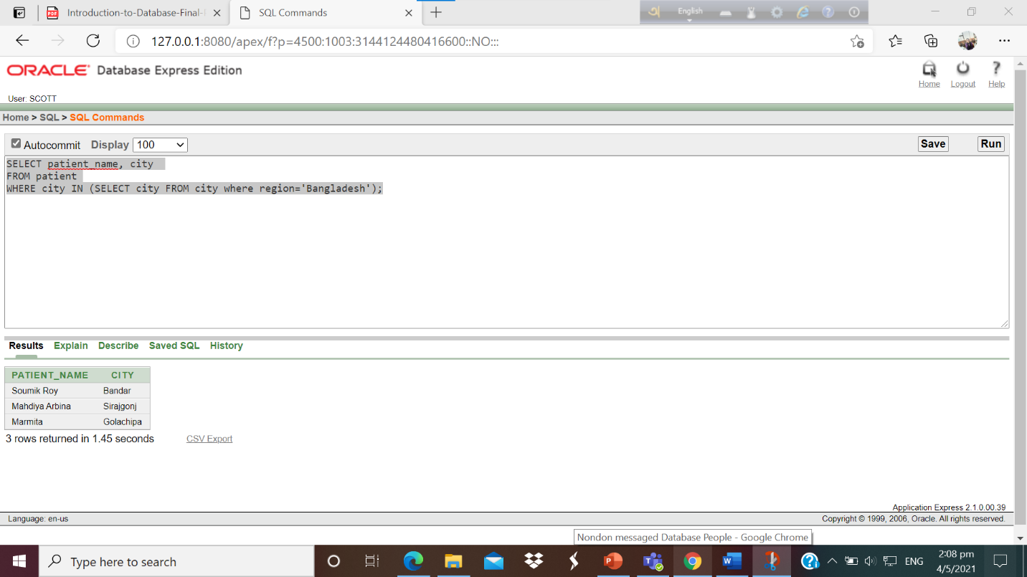

**2.Display the street_name along their street_number which is belong same region.**

select street_name,street_number

from city

where street_number=(select max(street_number)

from city

where street_number<(select max(street_number)

from city ))

**Screenshot:**

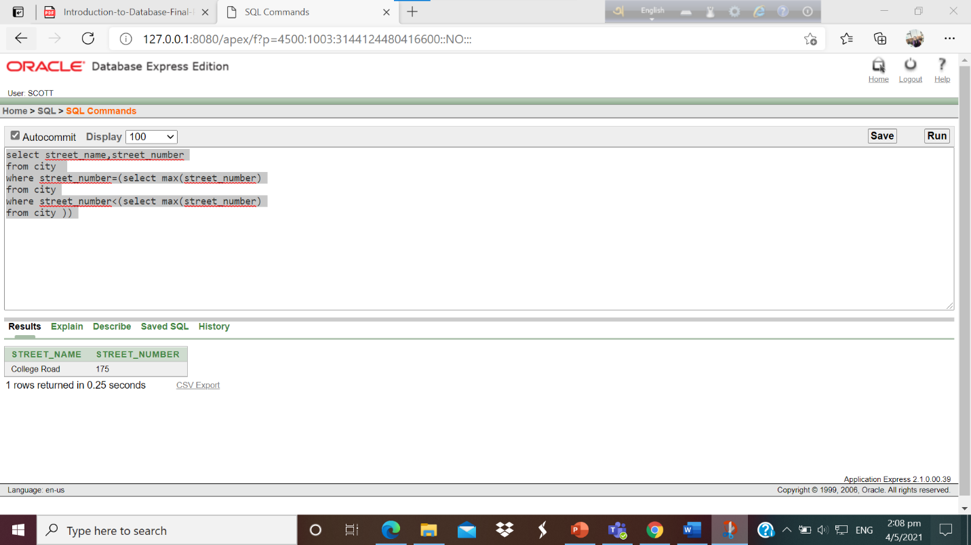

**3.** **Display the test_report_fee according highest fee of instrument**

select test_report_fee,instrument_fee

from test_report

where test_report_fee=(select max(test_report_fee)

from test_report

where test_report_fee<(select max(test_report_fee)

from test_report ))

**Screenshot:**

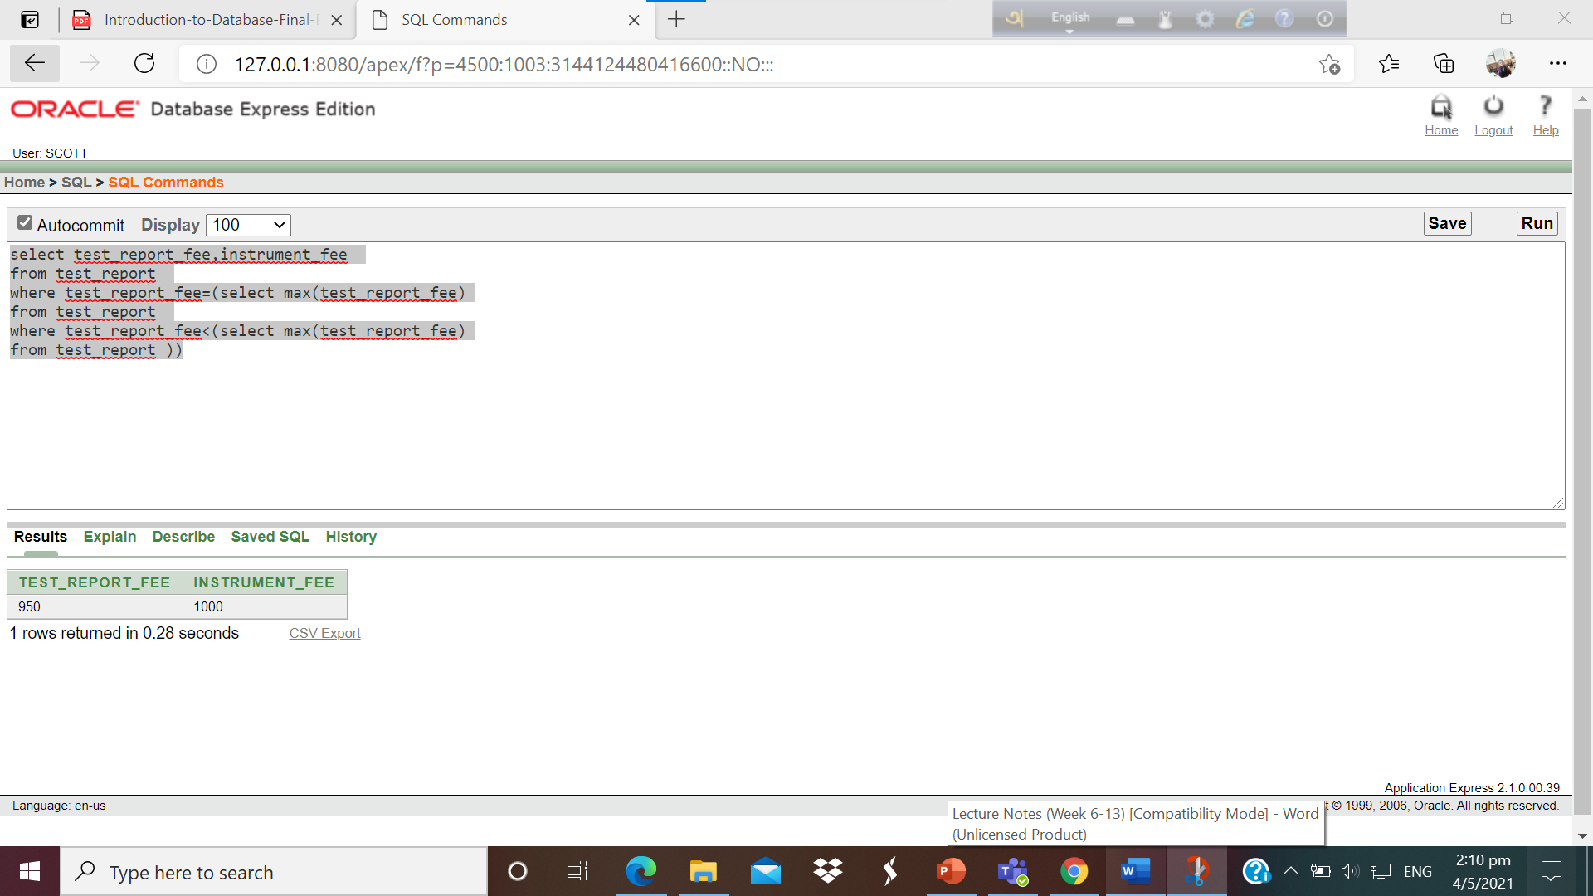

**4.** **Find the patient_name tested date in 2021.**

SELECT patient_id,patient_name, pgender

FROM patient

WHERE patient_id IN (

SELECT patient_id FROM patient_info1

WHERE ptesting_date > to_date('1-1-2021', 'dd-mm-yy')

);

**Screenshot:**

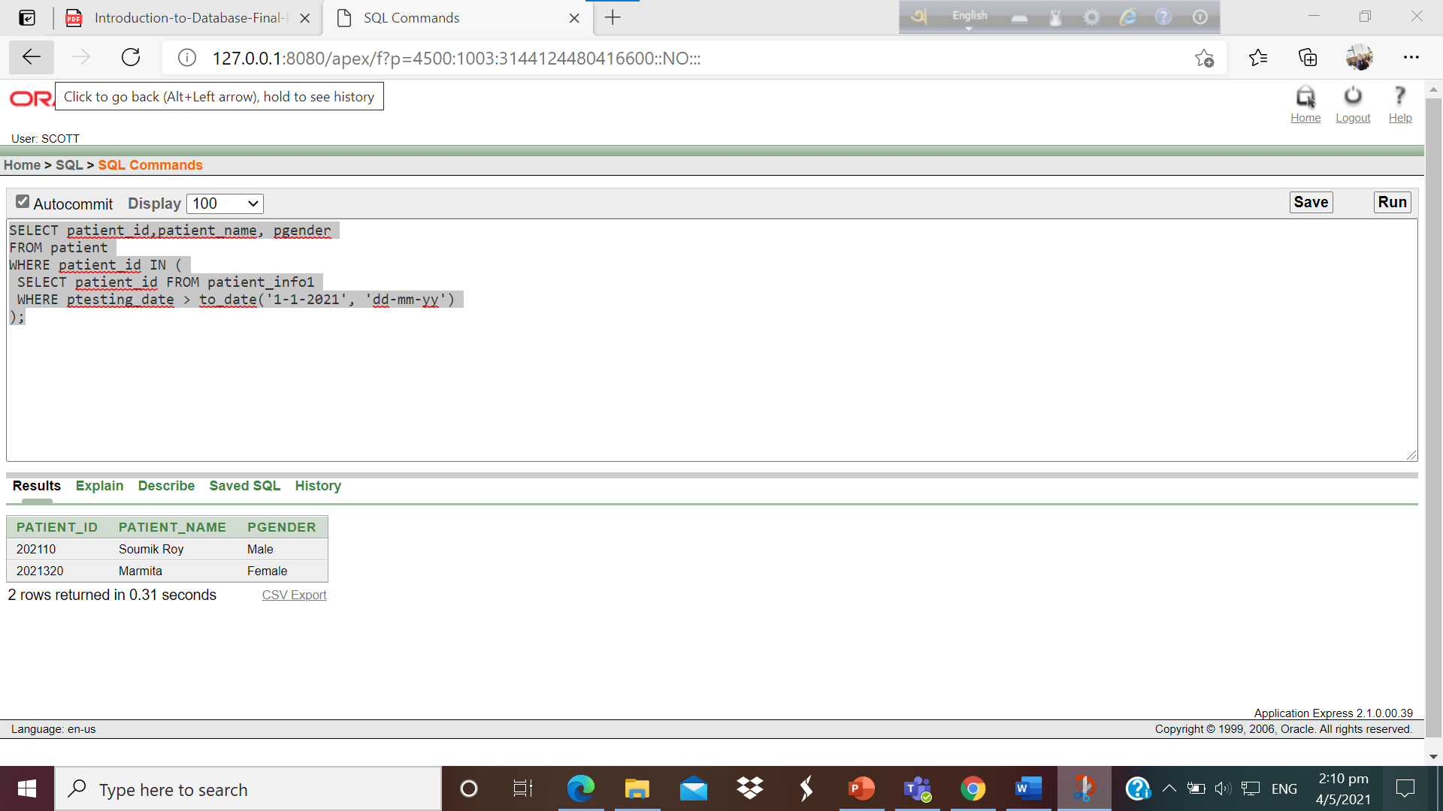

**View**

**Complex View 01:**

Create View Technician_Info

As Select Technician_Info1.Technician_Room_No,Technician_Info1.Technician_Name,Technician_Info2.Technician_Phone_No,Technician_Info2.Technician_Address

from Technician_Info1,Technician_Info2

where Technician_Info1.Technician_Phone_no=Technician_Info2.Technician_Phone_No;

**Screenshot:**

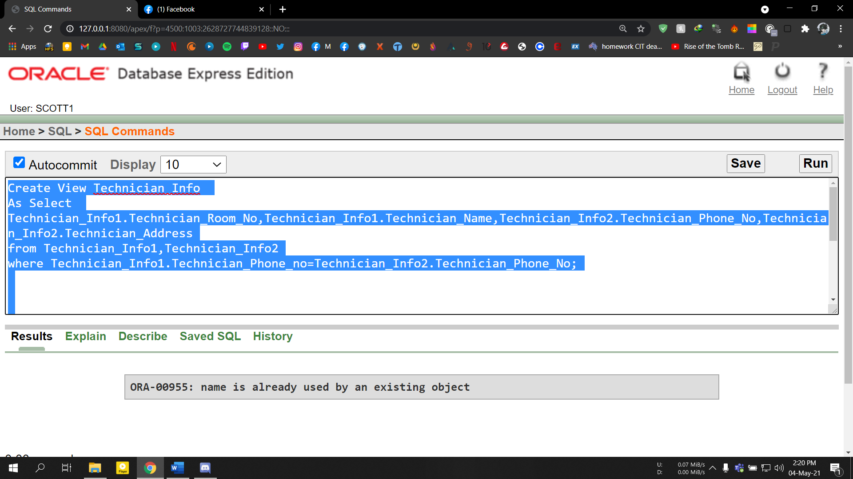

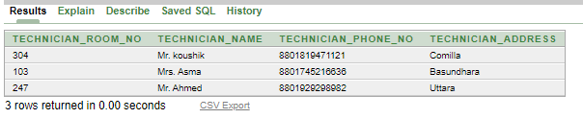

**Complex View 02:**

Create View Patient_info as select Patient.Patient_Id,Patient.Patient_Name,Patient_Info1.Test_Report,Patient_Info1.Ptesting_Date

from Patient,Patient_Info1

where Patient.Patient_Id=Patient_Info1.Patient_Id;

**Screenshot:**

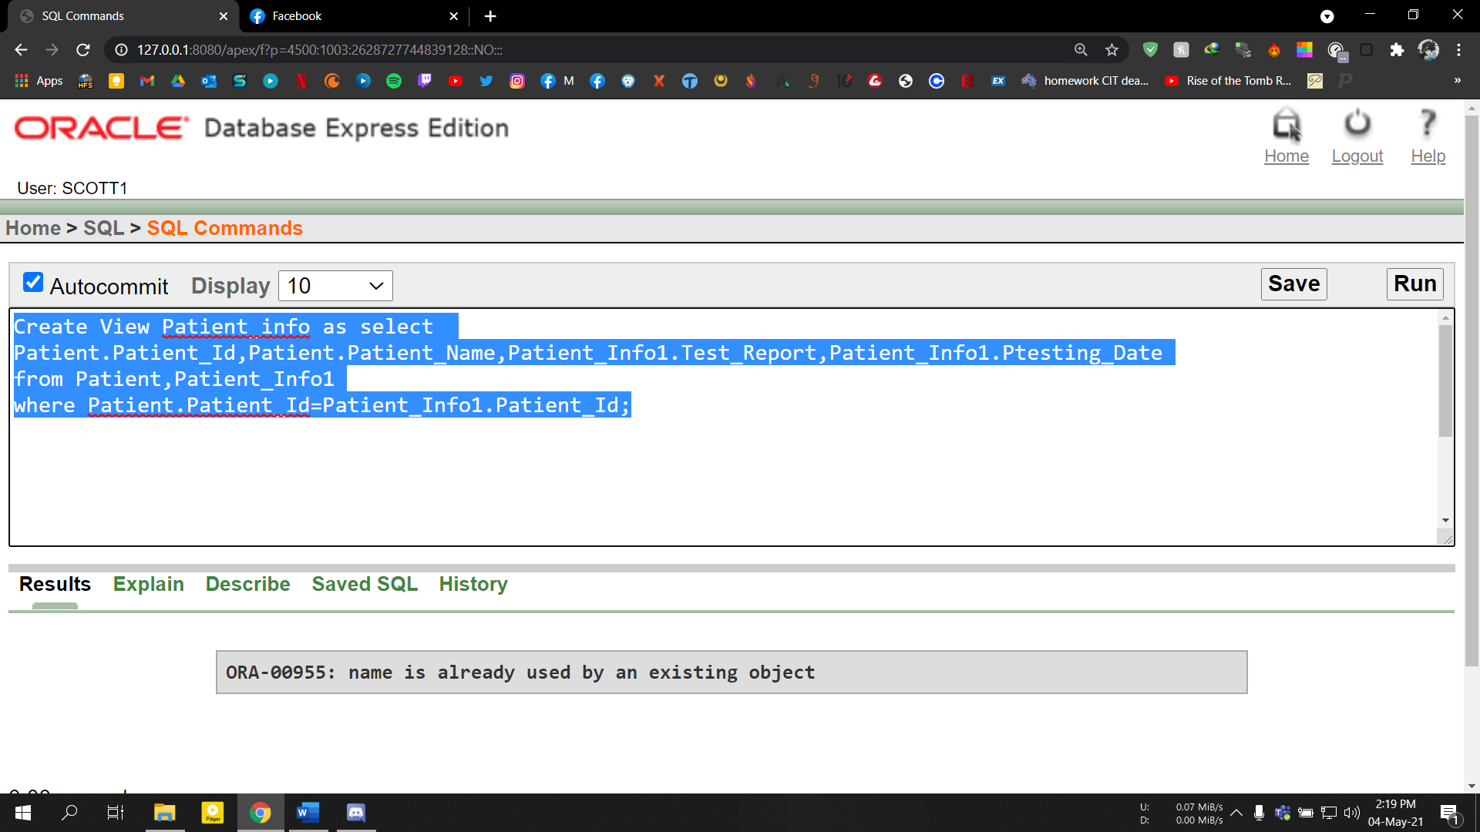

**Constraint Adding**

alter table Patient add constraint pk31 foreign key(City) references City(City);

**Screenshot:**

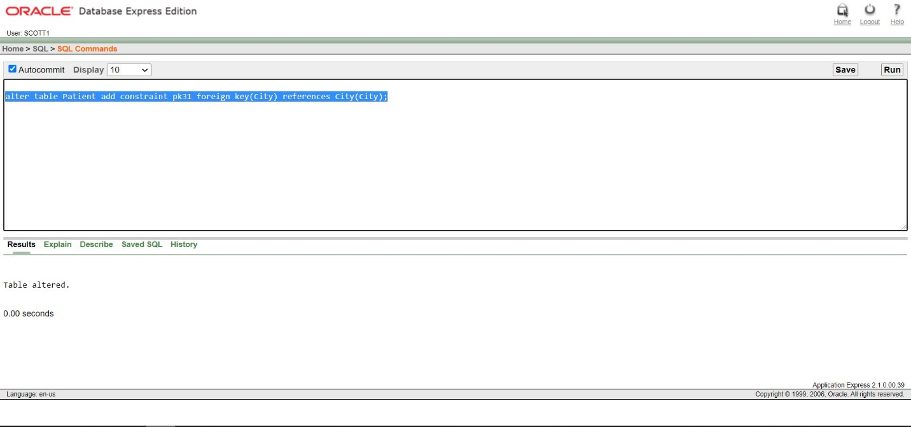

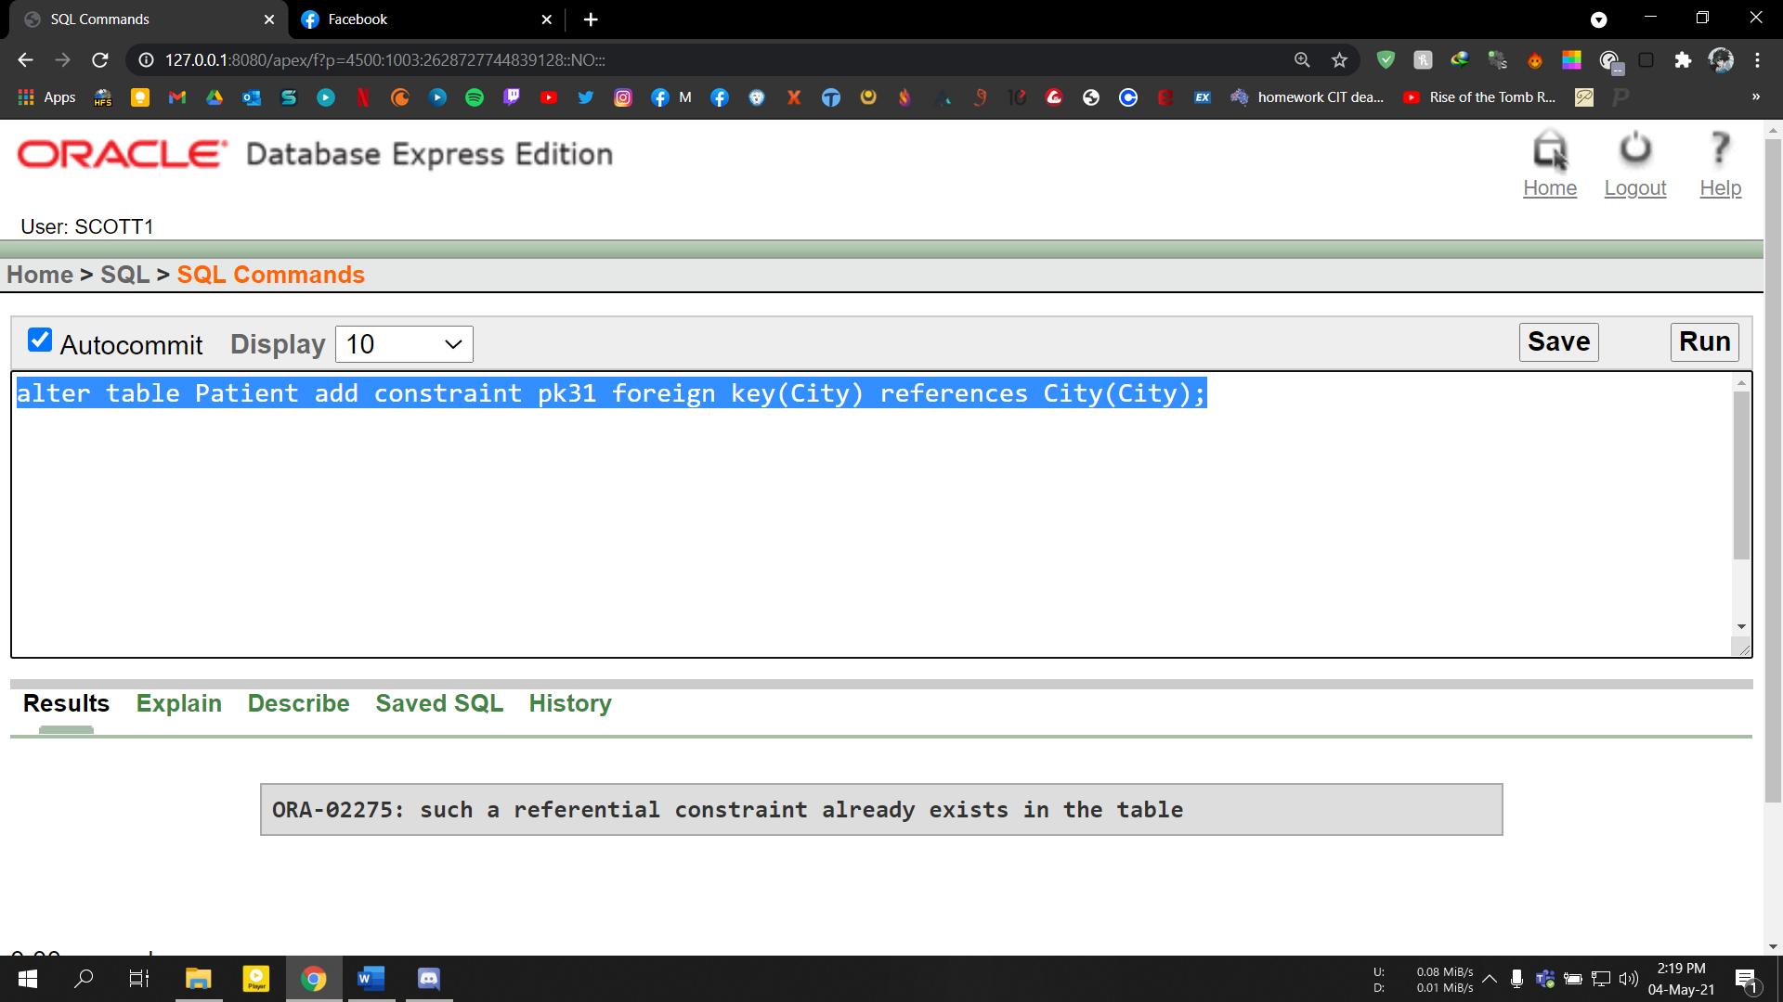

**History:**

